**EXPERIMENT NO. 04**

SIMULATION OF DYNAMIC ROUTING PROTOCOL (RIP) USING CISCO PACKET TRACER

**EXPERIMENT NO. 04**

**AIM: -** To simulate dynamic routing protocol (RIP) using Cisco Packet Tracer.

**OBJECTIVES:**

1. To simulate dynamic routing protocol, check the updated routing tables and check the connectivity among devices.
2. To debug RIP messages and understand how the routing tables are updated.
3. To analyze the routing tables.

**SOFTWARE:** Cisco Packet Tracer.

**SCENARIO:**

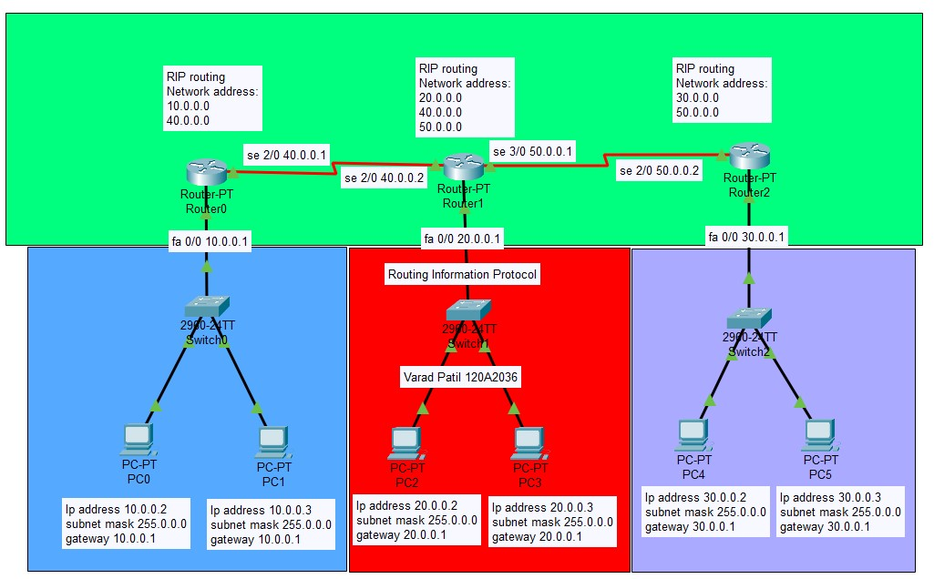

# CONFIGURATION OF FASTETHERNET0/0 INTERFACE OF Router0

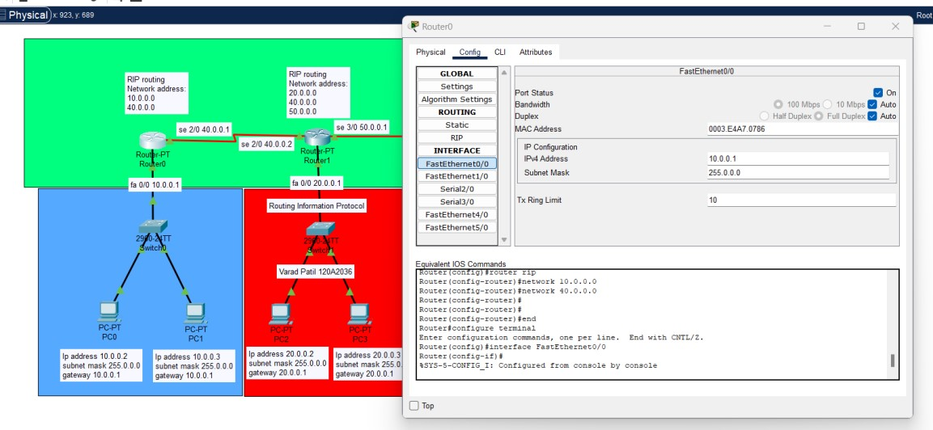

# CONFIGURATION OF SERIAL2/0 INTERFACE OF Router0

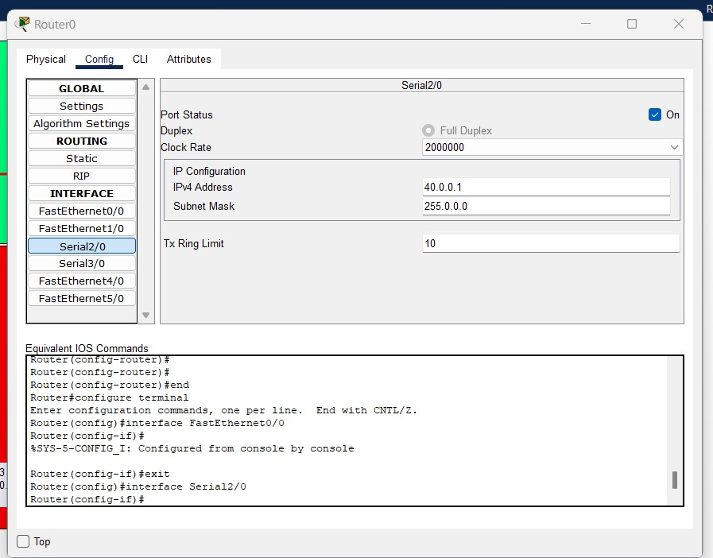

# CONFIGURATION OF SERIAL2/0 INTERFACE OF Router1

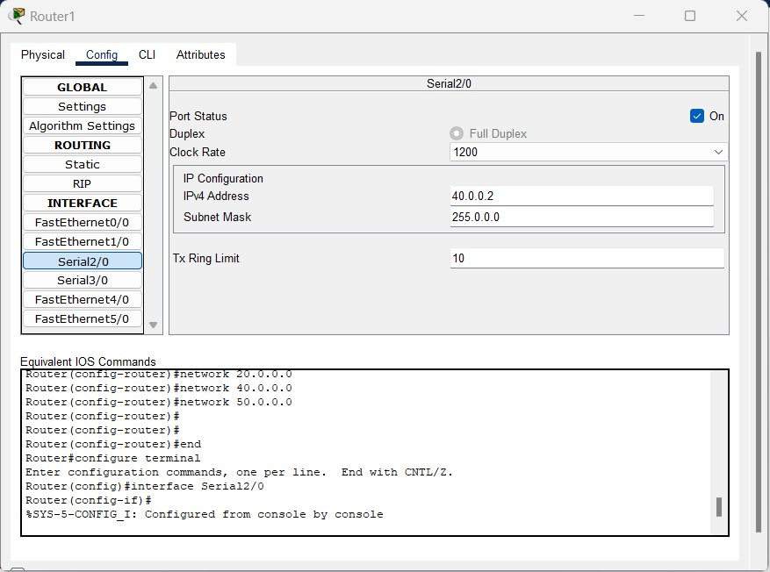

# CONFIGURATION OF SERIAL3/0 INTERFACE OF Router1

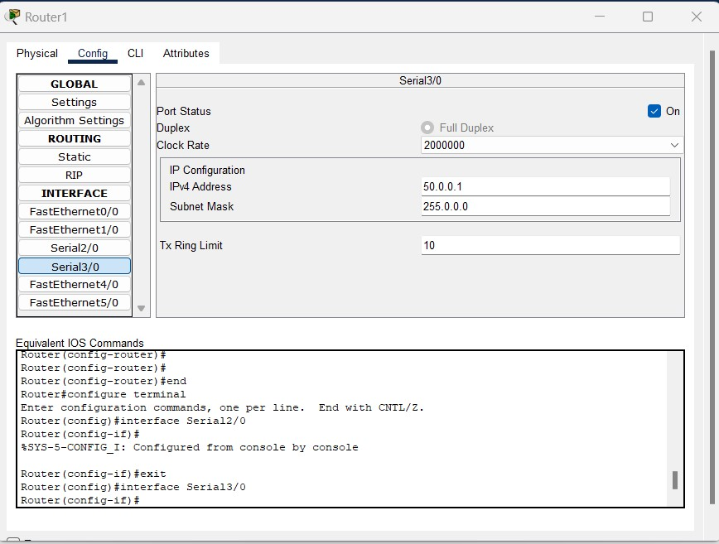

# CONFIGURATION OF FASTETHERNET0/0 INTERFACE OF Router1

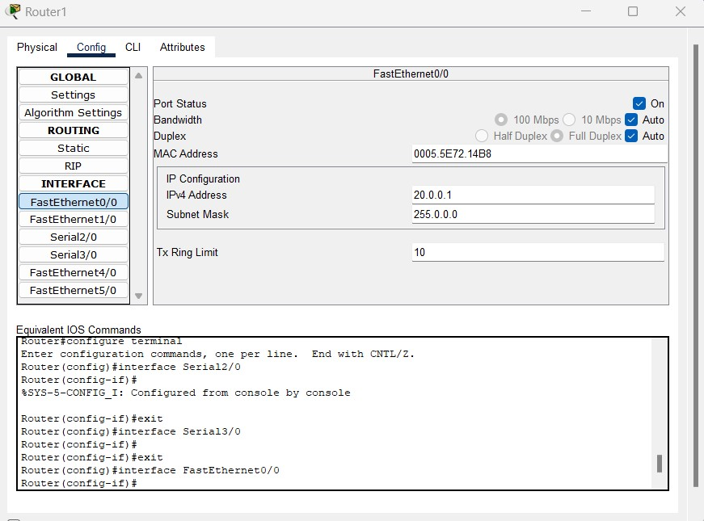

# CONFIGURATION OF SERIAL2/0 INTERFACE OF Router2

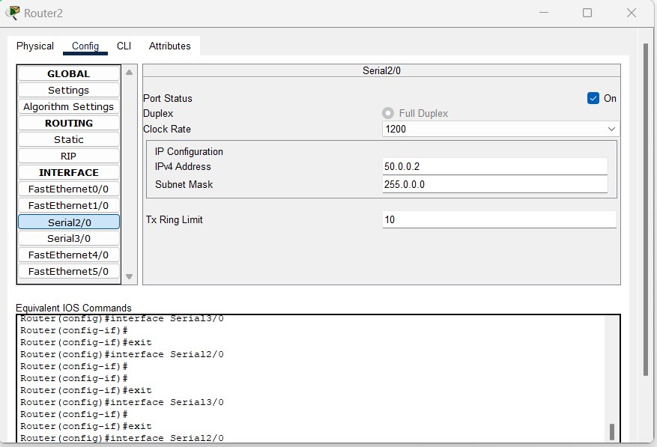

# CONFIGURATION OF FASTETHERNET0/0 INTERFACE OF Router2

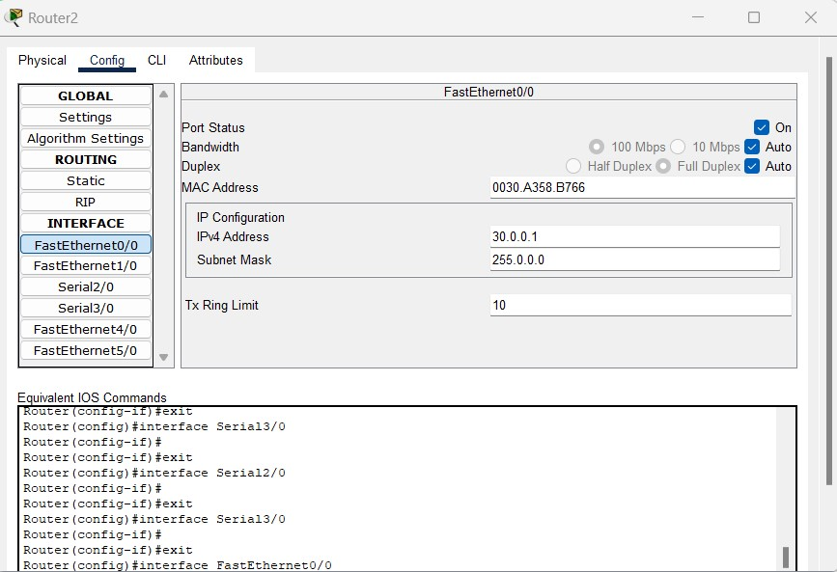

# ROUTER0 UPDATED TABLE

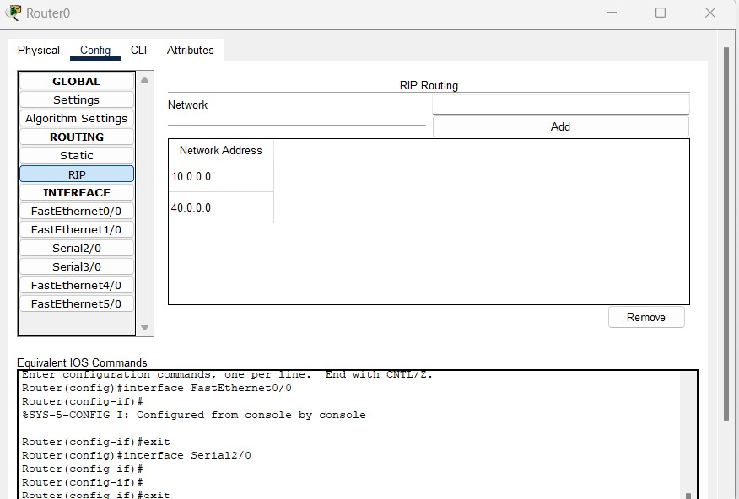

# ROUTER1 UPDATED TABLE

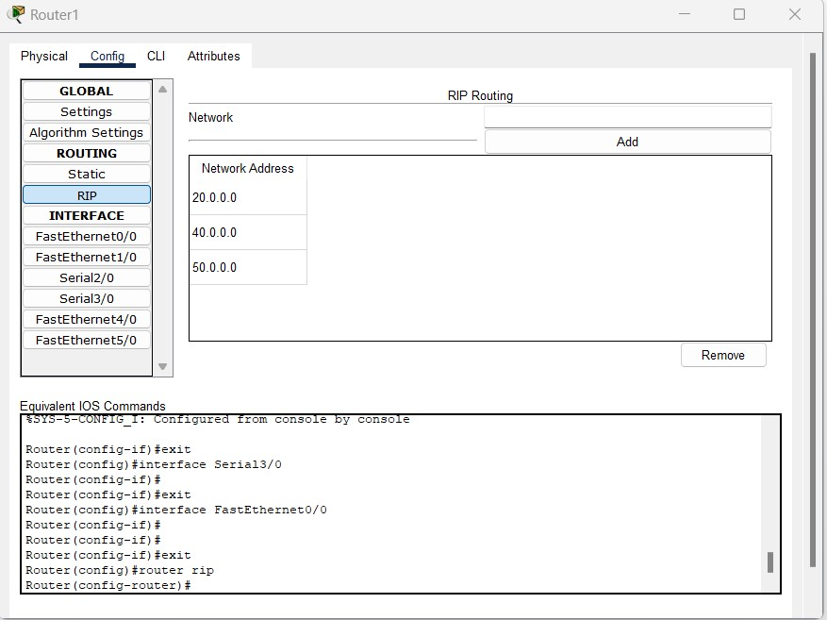

# ROUTER2 UPDATED TABLE

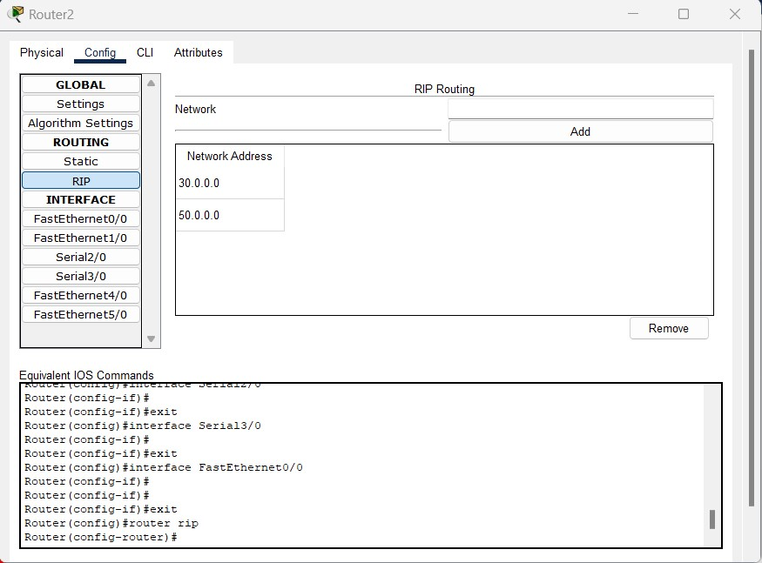

**PING RESPONSE**:

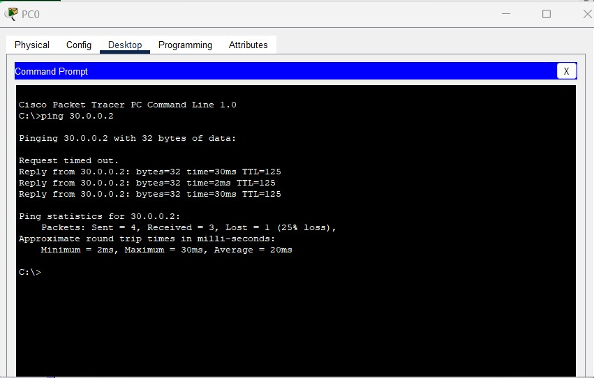

**CONCLUSION:**

In this experiment, we studied and performed the simulation of dynamic routing protocol (RIP) using Cisco Packet Tracer successfully and also checked the connections between three routers.